**Visvesvaraya Technological University**

# Belagavi, Karnataka, 590 014.



## **AICTE Activity Point Programme on**

**“Local Tourism through Innovative Approaches”**

(Non-Credit Activity of 2 Weeks (80-90 hours))

Submitted in partial fulfilment of the requirements for the award of

**Bachelor of Engineering**

**in**

**Computer Science and Engineering**

**Semester III**

**Academic Year 2021-2022**

***Department of Computer Science & Engineering***

|  |  |  |
| --- | --- | --- |
|  | K. L. E. SOCIETY’S**K. L. E. INSTITUTE Of TECHNOLOGY,**Opp. Airport, Gokul, Hubballi-580 030Phone: 0836-2232681 Website: www.kleit.ac.in | **kle-logo** |

### Chapter 1: Gokak fall

### Chapter 2 : Mini Niagra

### Chapter 3 : Mahalingeshwara Temple

### Chapter 4 : Godchinamalaki Falls

### Chapter 5: Restaurants and Amenities

### Chapter 6: Outdoor Activities in Gokak

|  |  |  |  |
| --- | --- | --- | --- |
|  | GOKAK FALLS | 2KE20CS004 | AKASH K HALEMANI |
|  | 2KE20CS023 | DHRUVKUMAR S. BAILKUR |
|  | 2KE20CS029 | HITESH BASANGOUDAR |
|  | 2KE20CS014 | ATTAR M RAISULHASAN |
|  | 2KE20CS039 | KUNTHUNATH MAHAVEER NANDAGAON |
|  | 2KE20CS114 | KOMAL K SAMBRANIKAR |
|  | 2KE20CS031 | KALKUTGI RAJNANDINI |
|  | 2KE20CS053 | POOJA GOTAKHINDI |
|  | 2KE20CS002 | ADITI ANANT NAIK |
|  | 2KE20CS122 | SEJAL PORE |
|  | 2KE20CS026 | GULANNAVAR AKSHATA HANUMANTA |
|  | 2KE20CS032 | KARTIK PRADEEP HEGADI |

**GOKAK FALLS**

ABSTRACT VIEW OF THE TOPIC

Gokak Falls is 6 km away from Gokak town and gets its name from the Goki trees found in abundance in these areas. It resembles the Niagara Falls due to its features like the fall, shape etc. Here, River Ghataprabha takes a leap of 52 metres over the sand-stone cliff amidst a picturesque gorge of the rugged valley, making a beautiful sight. This place has the credit of generating electricity for the first time in the country in about 1887. A prime attraction of the Gokak Falls is the hanging 200-m-long bridge that lies 14 m above the bedrock. Tourists can also visit monuments on both sides of the rocky gorge which include temples of Goddess Durga, Lord Shanmukha and Lord Mahalingeshwara built in the traditional Chalukyan style of architecture.

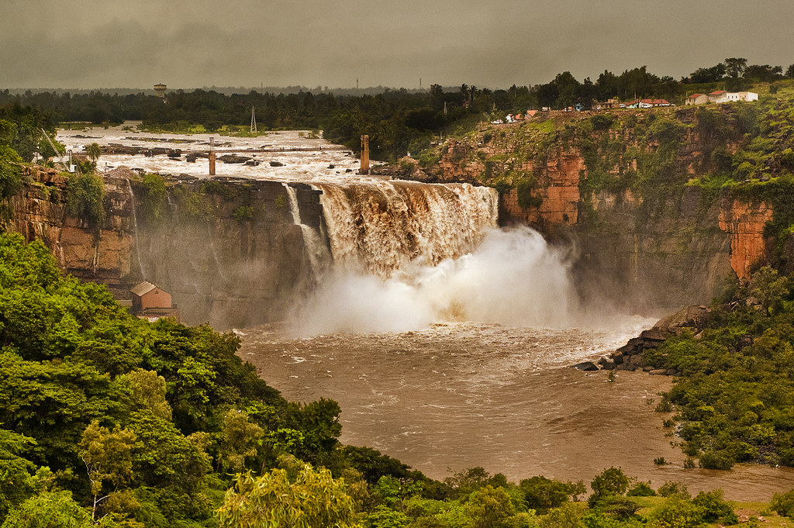

Fig 1.1

**HISTORY**

Gokak is a place of philosophical and historical significance. According to Hindu Purans, Gokak was a part of Kuntal Country; it was the land of hunting tribes. During historical period many emperors had ruled the Gokak areas: Shatavahanas ruled it during 327 BC to 229 CE, the Western Chalukyas ruled it during 550 CE to610 CE, then it was also ruled by Rastrakootas and Kalyana Chalukyas; the subordinate-kings of Rastrakootas called Ratts too ruled Gokak Province during 850 CE to1250 CE under Rastrakoots as well Kalyana Chalukyas, during this reign temples and Basadies were built at Konnur, Gokak-Falls, Gokak and Mamadapur. Devagiri Yadavas captured this areas after defeating Ratts but the Sultanas of Delhi took this areas under their control by defeating Yadavas.

Gokak taluka contributed to the Prime Minister's Relief Fund which was meant for humanitarian assistance for the Indian Ocean tsunami victims. Child Development Project Officer Mr P N Patil who addressed a press conference had disclosed that it was decided to donate a day's salary of government officials towards the relief fund. The employees of Forbes-Gokak textile industry also contributed about INR ₹ 7 lakh (₹ 700,000). Gokak is also known for its old Hindu Temples. Gokak is also renowned for its sweets, which are known all over India, such as Karadantu (a Kannada term, which literally means fried edible gum), a sweet richly stuffed with nuts and edible gum, and ladagi laadu.

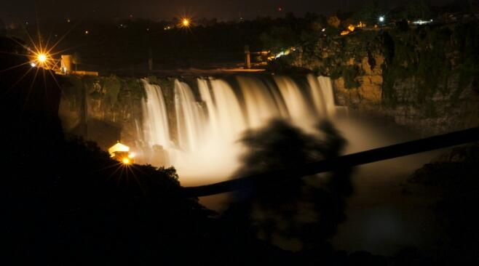

Fig 1.2

**SIGNIFICANCE**

* Hanging Bridge: Built across the river, 200 meters long, gives an elevated view of the falls.
* Lord Mahalingeshwara Temple, built-in Chalukya style architecture.
* Kemple Park botanical gardens
* Yogi Kolla hiking**:** A popular trekking destination 3 kms from the falls.
* Mallaprabha Boating**:** Boating options in Markandeya river, 8 kms from the Falls
* More temples**:** such as Yogikolla Mallikarjuna Temple, Kariyamma Temple, Laxmi Temple, Hanuman Temple and more.

# How to reach ?

The Falls is 622 kms from Bengaluru and 62 kms from [Belagavi](https://www.karnatakatourism.org/tour-item/belagavi/). Belagavi is the nearest airport and major railway station. Belagavi is well-connected by air, rail and road to rest of Karnataka. From Belagavi taxi can be hired to reach Gokak falls.

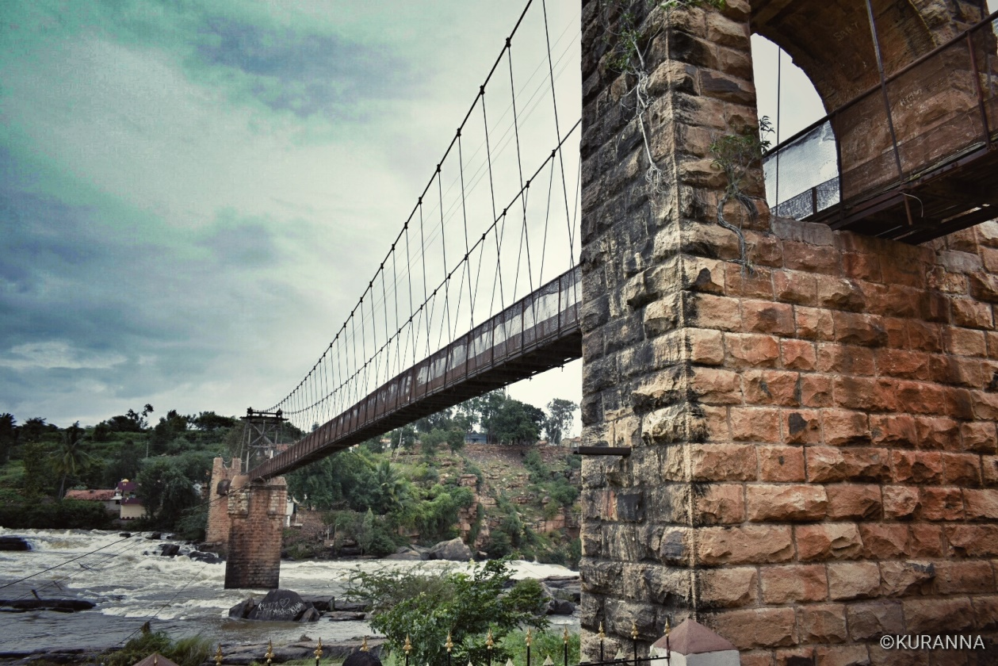

Fig 1.3

**LOCATION:**

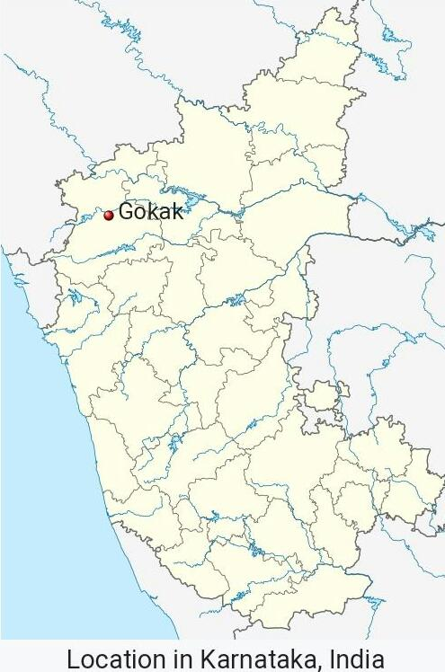

Fig 1.4

**STAY:** Gokak city, 6 kms away, has budget hotels. Belagavi city has more hotel options.

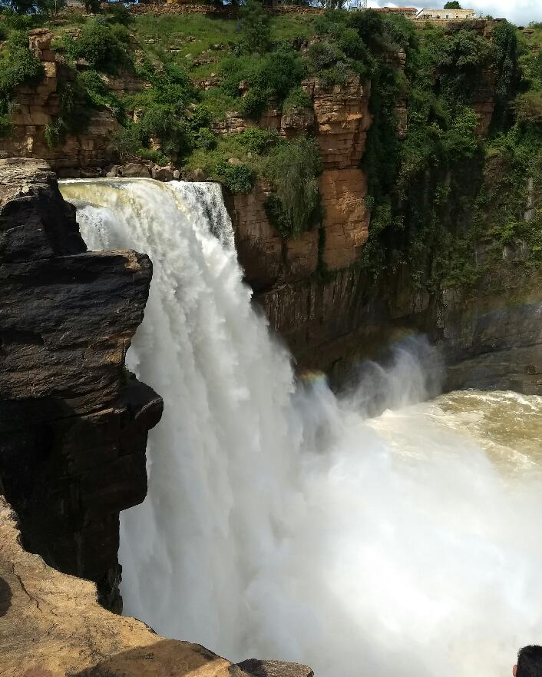

Fig 1.5

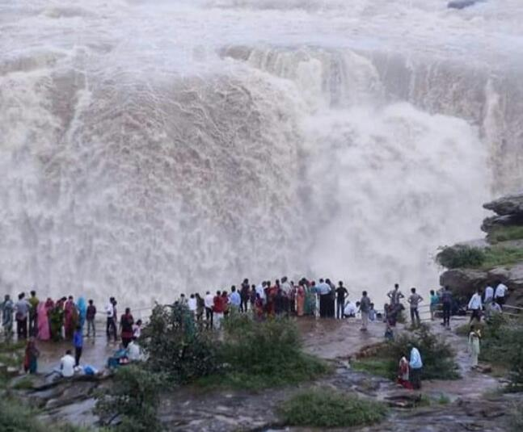

Fig 1.6

**VISITING THE NIAGARA OF KARNATAKA- GOKAK**

**ABSTRACT:**

Fig 2.1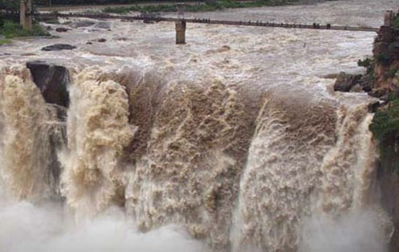

Gracefully flowing Ghataprabha river, after winding through a long route gushes down from 171 ft(52 metres) over sandstone cliff and rocky boulders to form beautiful looking Gokak falls. Besides this, the humongous waterfall has a flood width of 170 metres and its resemblance in many ways are similar to that of Niagara falls in the USA. Hence, It is also popularly known as “ Mini Niagara” by the locals. Gokak got its name from the Goki river that runs in this region.

**HISTORY**

Fig 2.2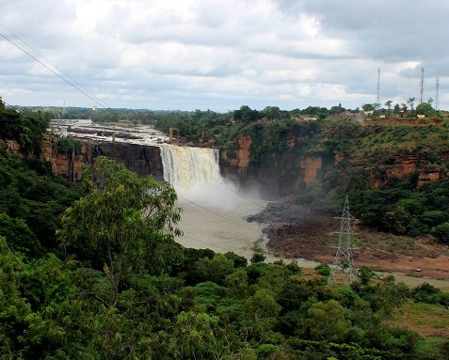

Gracefully flowing Ghataprabha river,

after winding through a long route gushes down from 171 ft(52 metres) over sandstone

cliff and rocky boulders to form beautiful looking Gokak falls.

Besides this, the humongous waterfall has a flood width of 170 metres and its resemblance in many ways are similar to that of Niagara falls in the USA

Hence, It is also popularly known as “ Mini Niagara” by the locals. Gokak got its name from the Goki river that runs in this region.

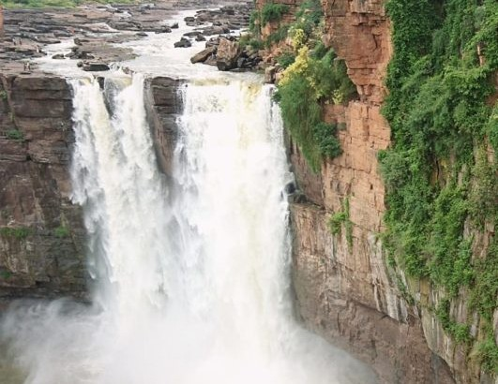

Fig 2.3

Shortly before the falls, a 201 meter long suspension bridge was built to facilitate traffic on the river banks Walk on this bridge is a thrill.

There is also a beautiful garden near this waterfall.

Gokak Waterfalls in El Sheep One of the major tourist attractions in Karnataka, thousands of people come here to see this waterfall.

**Location**

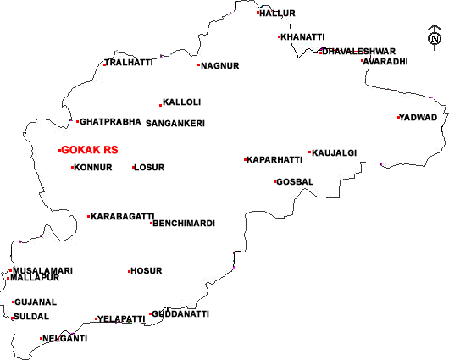

Fig 2.4 Gokak Falls – Mini Niagara, Belagavi

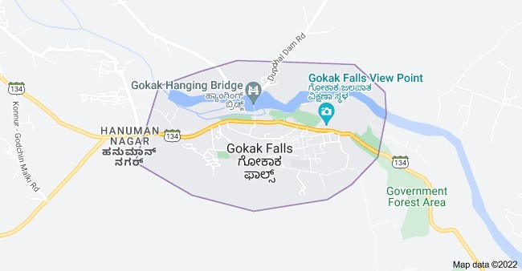

Fig 2.5

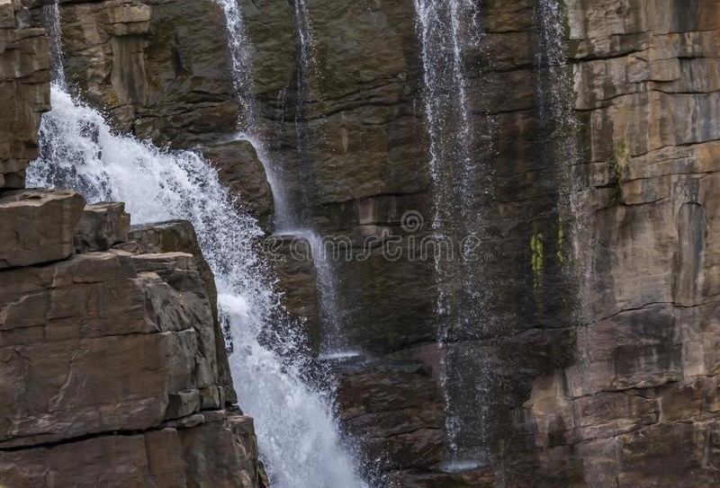

Fig 2.6

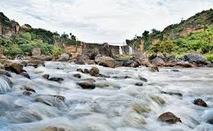

Fig 2.7

Mahalingeshwara Temple

**Abstract:**

**Mahalingeshwara Temple** (mentioned as **Tarakeshwar temple** in an old inscription found inside the temple belonging to the reign of Ratta Kartaveerya III, dating back to 1153 AD) is an 11th-century Hindu temple dedicated to lord shiva. It is located at Gokak Falls, Belgaum. It has been built in Kalyani Chalukyan architectural style. It boasts of having a huge courtyard, an Ardhamandapa and a spacious open mukhamantapa(frontal courtyard) and a Garbhagriha(sanctum santorum) over which there exist a beautifully carved shrine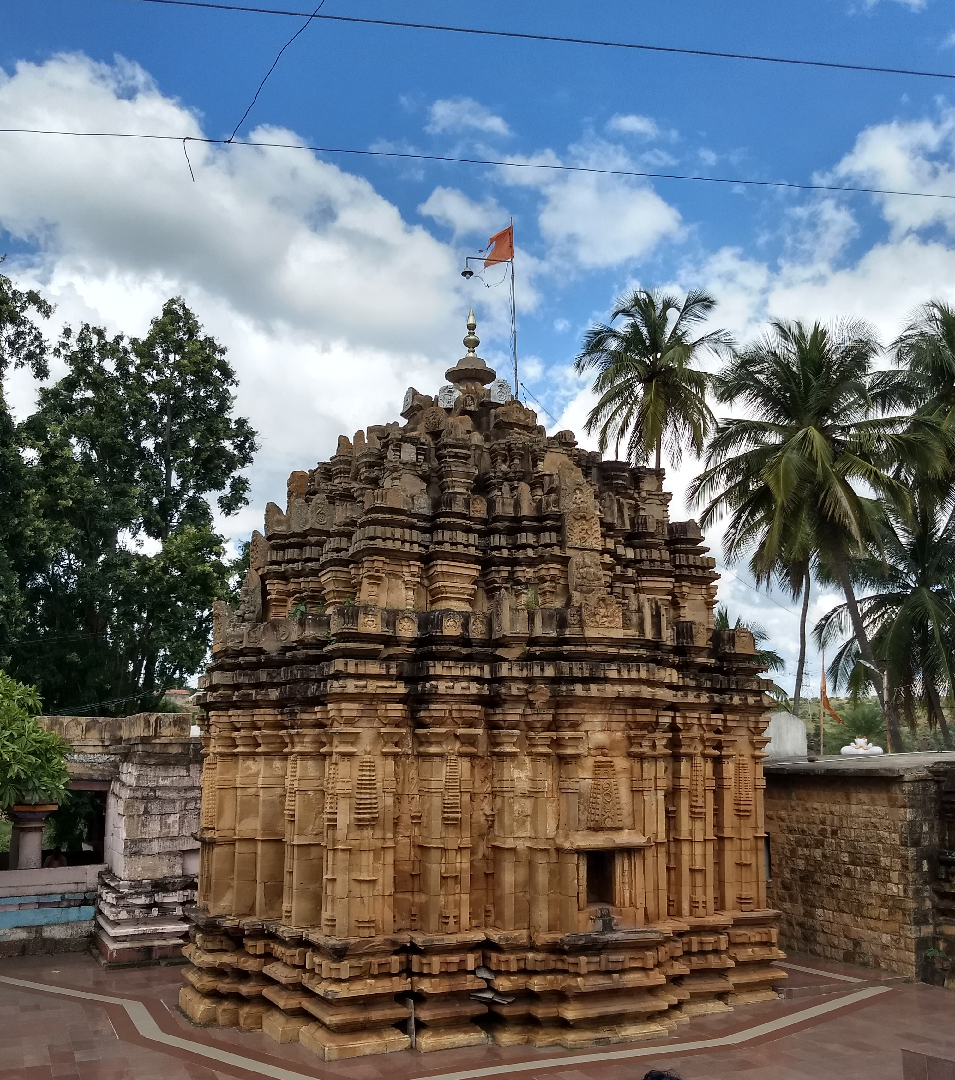

Fig 3.1

**History**

The temple is dedicated to Lord Mahalingeshwara, built in the Kalyani Chalukyan style, faces the cotton mill and flanks one side of the gorge. Locally known as Tarakeshwara temple, the temple boasts of a huge courtyard and has a sanctum sanctorum over which looms a tower that is adorned with exquisite carvings.

**About Kalyani Chalukyan style**

**The basic floor plan** is defined by the size of the shrine, the size of the sanctum, the distribution of the building mass, and by the [pradakshina](https://en.wikipedia.org/wiki/Pradakshina) (path for circumambulation), if there is one.

**Architectural articulation** refers to the ornamental components that give shape to the outer wall of the shrine. These include projections, recesses, and representations that can produce a variety of patterns and outlines, either stepped, stellate (star-shaped), or square.[[21]](https://en.wikipedia.org/wiki/Western_Chalukya_architecture%23cite_note-wall2-21) If stepped (also called "stepped diamond of projecting corners"), these components form five or seven projections on each side of the shrine, where all but the central one are projecting corners (projections with two full faces created by two recesses, left and right, that are at right angles with each other).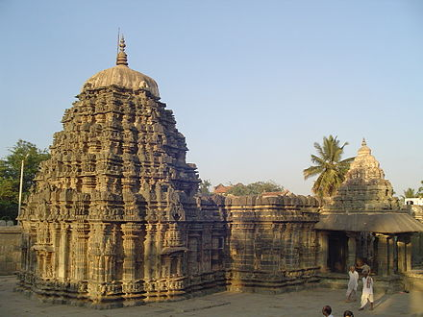

Amrtesvara Temple in Annigeri was built in the [Dharwad district](https://en.wikipedia.org/wiki/Dharwad_district) in 1050 CE with *dravida* articulation. This was the first temple made of [soapstone](https://en.wikipedia.org/wiki/Soapstone).

Fig 3.2



Fig 3.3 Thomas Biggs Architect

Mahalingeshwara Temple, on the south side of the Gokak Waterfalls, is an important antiquated river-front temple. Dedicated to Lord Shiva, this temple is locally called as **Takakeshwara Temple**.

Photograph of the Tateshwara Temple near the Gokak Falls in Karnataka, taken by Thomas Biggs around 1855, from 'Architecture in Dharwar and Mysore'. The Gokak Falls, near Belgaum, are created by the Ghataprabha river which takes a 170-ft leap over a sandstone cliff in a picturesque gorge with a horse-shoe shape. On the sides of the river are several temples dating from the period of the Later Chalukyas of Kalyana who ruled portions of the Deccan from the 10th to the 12th centuries. The Tateshwara temple is a Shiva temple on the south side of the falls. It faces north, an unusual orientation for Shiva temples. It has a sanctuary with a mandapa or hall. The outside walls of the closed hall are from recent times.

**Significance**

Devotees visit this temple to seek fulfillment of the following:

Mahalingeshwara Temple (mentioned as Tarakeshwar temple in an old inscription found inside the temple belonging to the reign of Ratta Kartaveerya III, dating back to 1153 AD) is an 11th-century Hindu temple **dedicated to lord shiva**.

Salvation Wealth Relief from diseases Purchase of vehicles Gain Knowledge

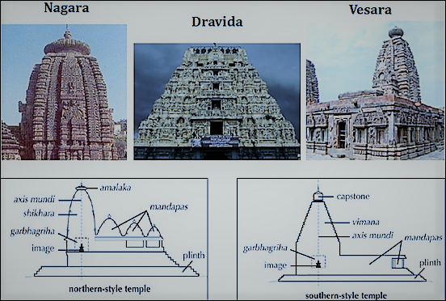



Fig 3.5 Various styles of temples

**How To Reach Mahalingeshwar Temple, Karnataka?**

**Airport**

The Bangalore Airport is the main airport in Karnataka. It is very well connected to the rest of India.

**Railways**

Ghataprabha Railway Stationnear Gokak is the nearest railhead.

**Road**

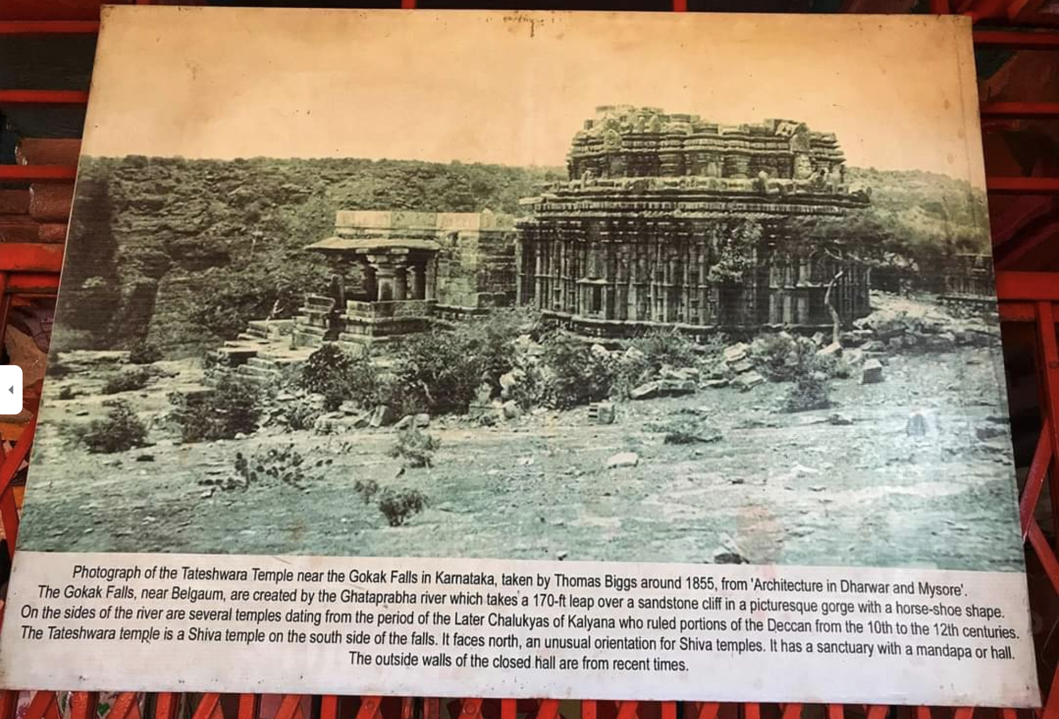

Old Photo

Gokak is 65 km by road from Belgaum and is well connected by public transport.

**Temple Address**

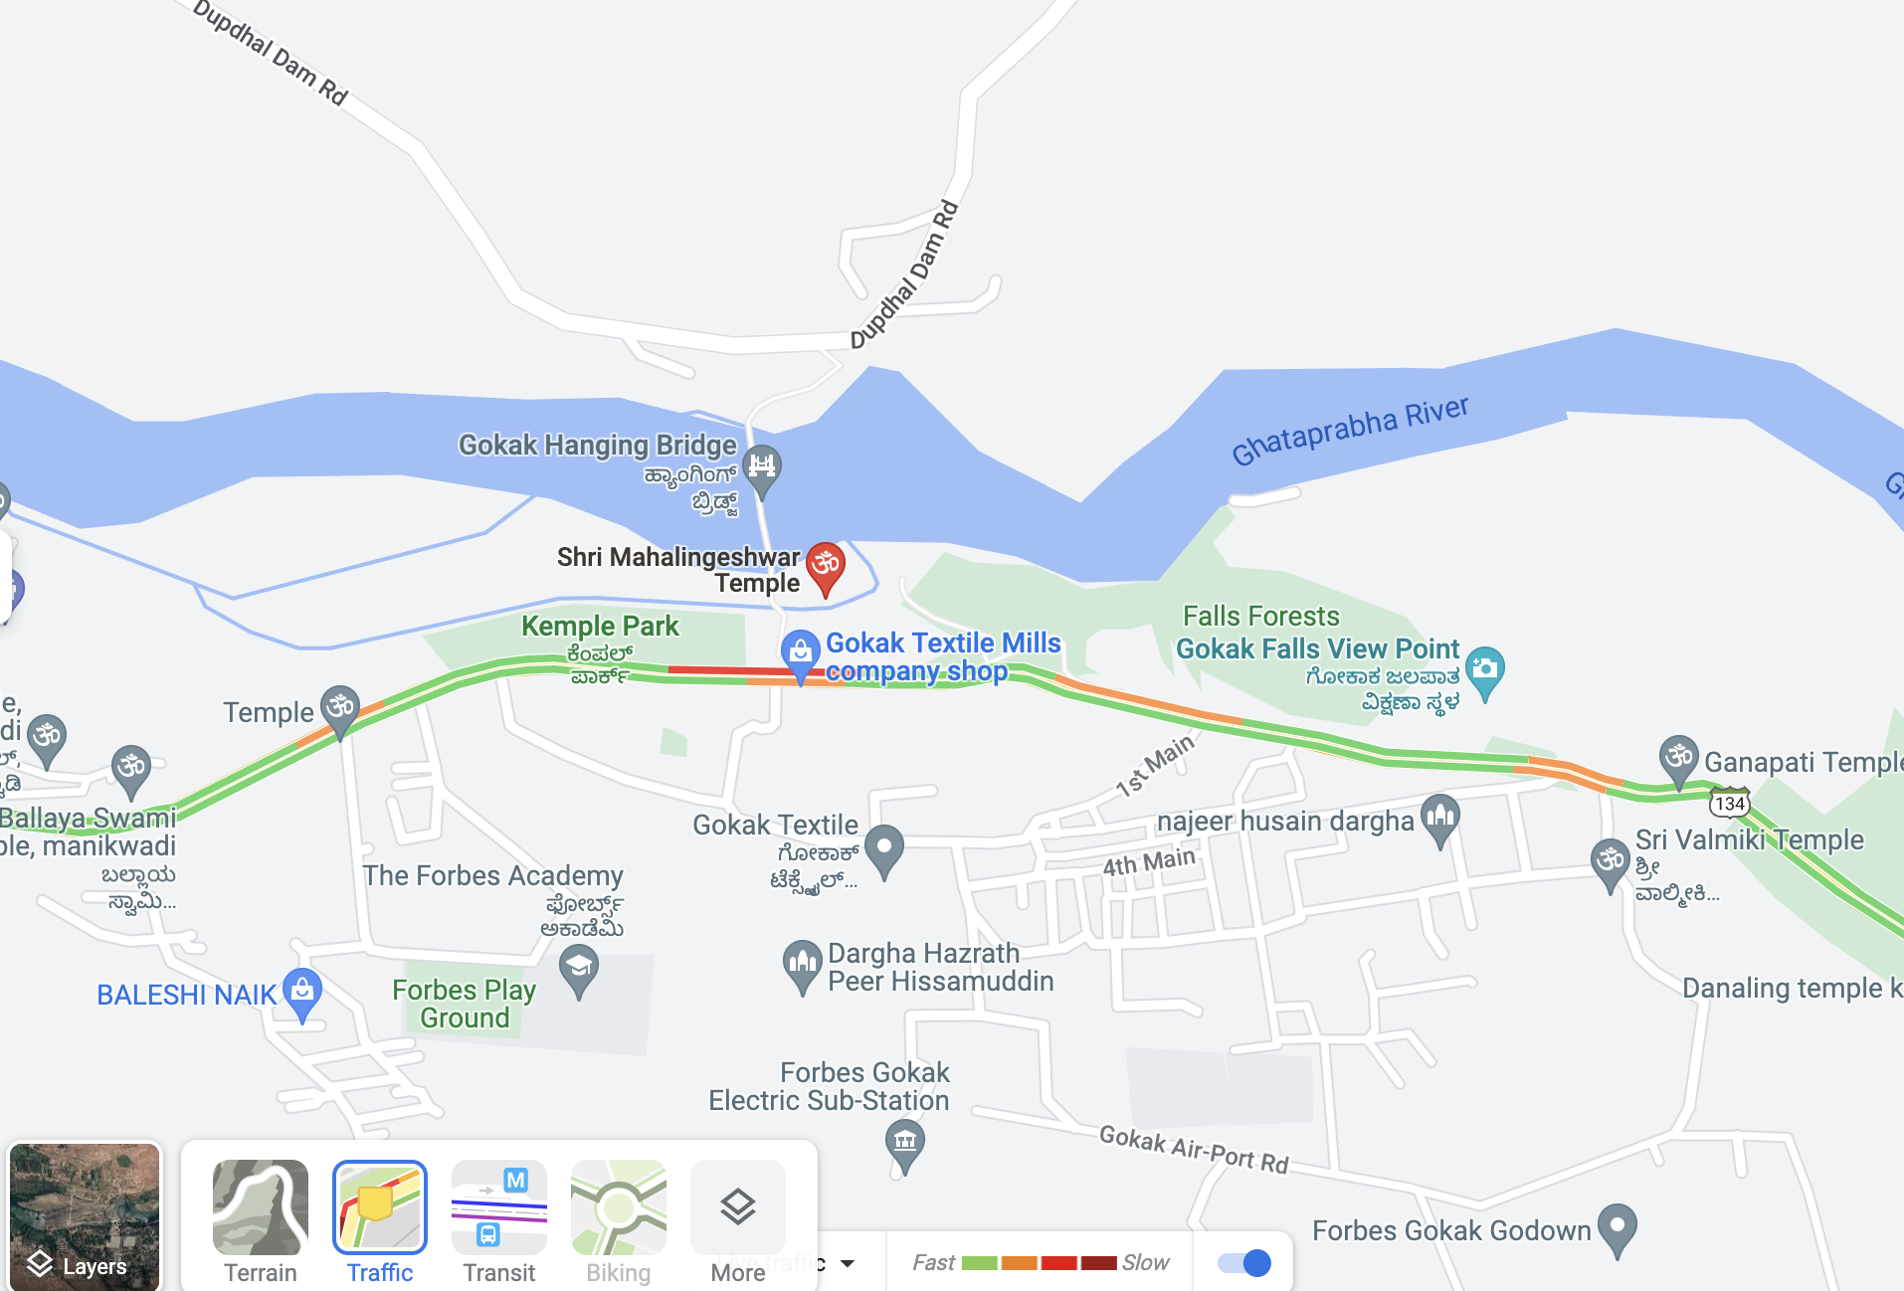

Shri Mahalingeshwar Temple,

Vivekanand Nagar, Gokak Falls,

Karnataka - 591308.

Fig 3.6

Shlokas

Kailaasarana Shiva Chandramouli Phaneendra Maathaa Mukutee Zalaalee Kaarunya Sindhu Bhava Dukha Haaree Thujaveena Shambho Maja Kona Taaree

Meaning -Oh Lord Shiva who is seated on Mount Kailash, where the moon decorates his forehead and the king of serpents crown his head, who is merciful and removes delusion, You alone can protect me. I surrender to thee.

Timings

The temple is open from 6 A.M to 9 P.M

Stay

Hotel Gokak Resort

- <https://goo.gl/maps/kDoBS7fCqVwiZPV56>

The Landmark Hotel - [https://g.page/The-landmark-boutique](https://g.page/The-landmark-boutique-hotel?share)-hotel?share

SPOT ON 46421 Mahalaxmi Residency

- <https://goo.gl/maps/9ZFsNBMDfbHbdBFu8>

SPOT ON 47279 Hotel Anmol

- <https://goo.gl/maps/fyD9BVWKKCSa97Dx6>

**Godchinamalaki Falls**

**Godachinmalki Falls** in [Godachinamalaki](https://en.wikipedia.org/wiki/Godachinamalaki) village is a [waterfall](https://en.wikipedia.org/wiki/Waterfall) located on [Markandeya river](https://en.wikipedia.org/wiki/Markandeya_River,_Western_Ghats) in [Belgaum](https://en.wikipedia.org/wiki/Belgaum) district, Gokak Taluk, [Karnataka](https://en.wikipedia.org/wiki/Karnataka), [India](https://en.wikipedia.org/wiki/India). It is 15 kilometers away from [Gokak](https://en.wikipedia.org/wiki/Gokak) and 40 kilometers from Belgaum. It is located in a deep green valley.

Fig 4.1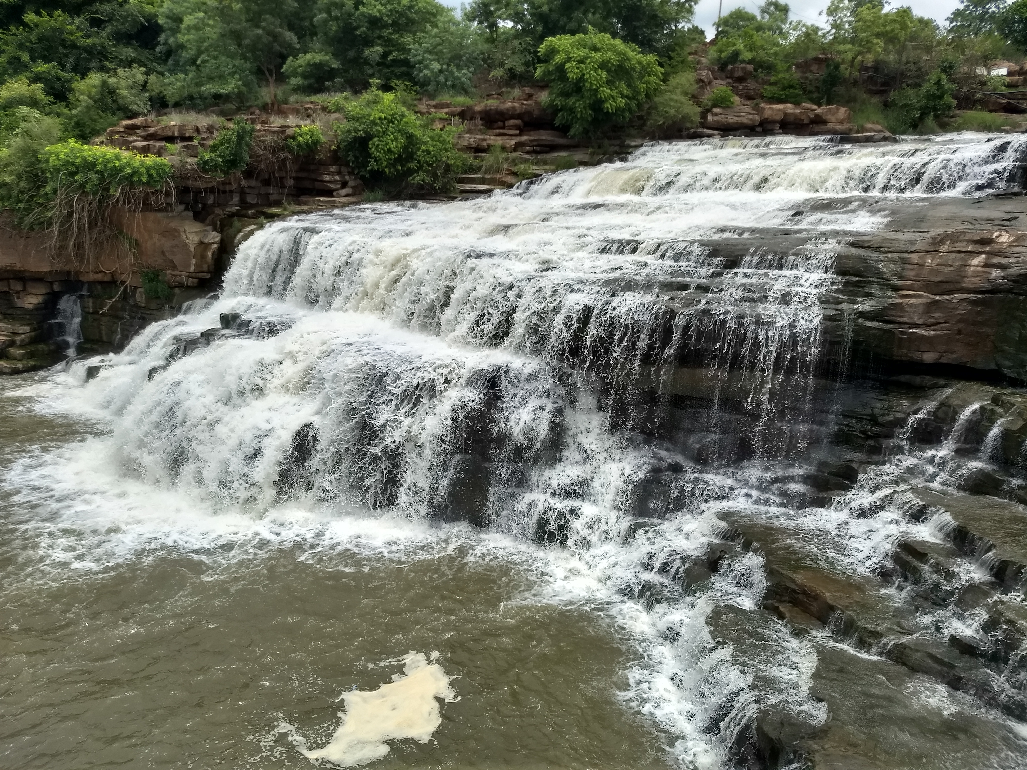

**More about the falls**

Godachinmalki falls, also known as Markandeya falls, is located in a rugged [valley](https://en.wikipedia.org/wiki/Valley), which is approachable from [Godachinamalaki](https://en.wikipedia.org/wiki/Godachinamalaki) village by walking as well as by vehicle through an irregular [forest](https://en.wikipedia.org/wiki/Forest) route for about 2 kilometers and there are two routes to reach the falls from Godachinamalki, one is vai Malebail road by crossing bridge at godachinamalki and another one is vai Gurusiddeshwar Temple(Hatti Siddeshwar). It can also be reached from Nirvaneshwara Matha near Yogikolla, only by foot.

To reach Godachinamalki Falls from Belgaum vai Ankalagi, Pachhapur & Mavanur, frequent bus facility is available from Belgaum & Gokak and nearest railway station is Pachhapur, which is about 8 kilometers and good train facility is available from Belgaum to Miraj, all most all trains stops in Pachhapur railway station .

There are actually two falls formed here. The [Markandeya river](https://en.wikipedia.org/wiki/Markandeya_River,_Western_Ghats) takes a first fall from a height of about 25 metres and flows into a rocky valley. After a short distance from the rocky valley, it takes the second fall from a height of about 20 metres.

Within 10 km distance Gokak falls is located from Godachinamalki vai Melmanahatti & Maradimath.

Later [Markandeya river](https://en.wikipedia.org/wiki/Markandeya_River,_Western_Ghats) joins [Ghataprabha River](https://en.wikipedia.org/wiki/Ghataprabha_River) near [Gokak](https://en.wikipedia.org/wiki/Gokak).

Within a 6 km radius there are two dams; one built across [Ghataprabha River](https://en.wikipedia.org/wiki/Ghataprabha_River) (Hidkal dam) and another one (Shirur Dam) across [Markandeya river](https://en.wikipedia.org/wiki/Markandeya_River,_Western_Ghats). The best time to visit these places is from June to September[[1]](https://en.wikipedia.org/wiki/Godchinamalaki_Falls#cite_note-1)

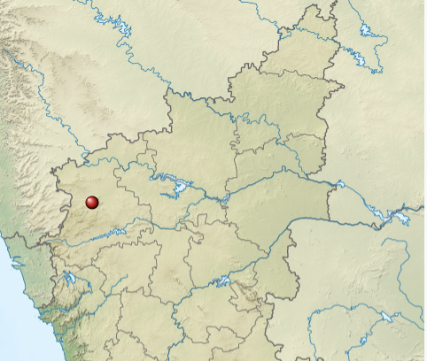

Fig 4.2

|  |  |
| --- | --- |
| **Location** | [Godachinamalaki](https://en.wikipedia.org/wiki/Godachinamalaki) |
| [Coordinates](https://en.wikipedia.org/wiki/Geographic_coordinate_system) | [16°7′54.73″N 74°43′49.98″E](https://geohack.toolforge.org/geohack.php?pagename=Godchinamalaki_Falls&params=16_7_54.73_N_74_43_49.98_E_type:waterbody_scale:50000)  [Coordinates](https://en.wikipedia.org/wiki/Geographic_coordinate_system): [16°7′54.73″N 74°43′49.98″E](https://geohack.toolforge.org/geohack.php?pagename=Godchinamalaki_Falls&params=16_7_54.73_N_74_43_49.98_E_type:waterbody_scale:50000) |
| [Type](https://en.wikipedia.org/wiki/Waterfall#Types) | Ledge Waterfall |
| **Total height** | 45 metres (147 feet) |
| **Number of drops** | 2 |
| **Longest drop** | 25 metres (2 feet) |
| **Watercourse** | [Markandeya river](https://en.wikipedia.org/wiki/Markandeya_River,_Western_Ghats) |

**Highlights of the Falls:**

Highlights of the Falls:

* **Breathtaking view**: The large open valley, mist forming by roaring waterfall makes Godachinamalki a visual treat
* **Trekking opportunity**: Though accessible by road, trekking the last few kilometres from Godachinamalki village till the falls is a popular activity.

**Best season to visit:**July to October is the best season to visit Falls as water levels will be high and experience will be at its best.

**Nearby:** A visit to Godachinamalki falls can also be extended to include Gokaka falls (14 kms) and Hidkal Reservoir (22 kms).

**Outdoor Activities in Gokak**

The travellers can live up some of the popular adventure recreational activities to the fullest such as waterskiing, white water rafting, windsurfing, kayaking, and others.



Fig 4.3: Waterskiing

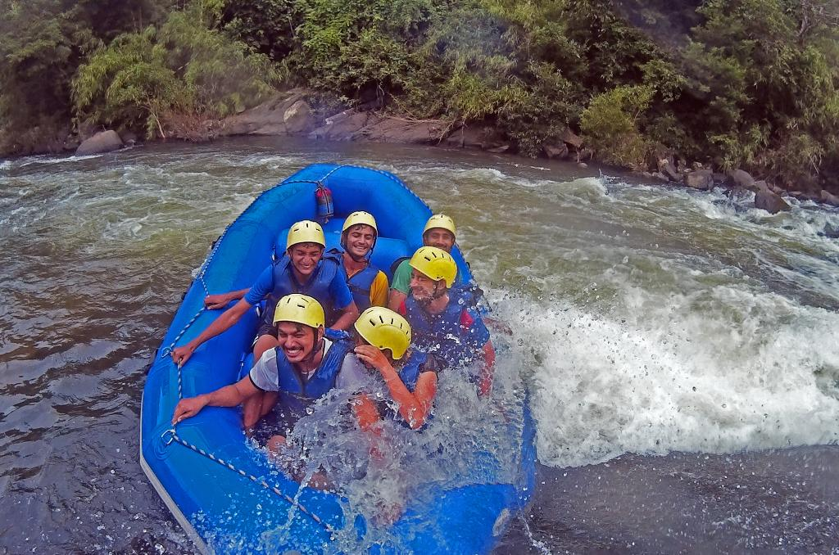

Fig 4.4: White Water Rafting



Fig 4.5: Kayaking

In a huge boost for the pandemic-hit tourist sector, the government has allowed kayaking at Gokak Falls in Belgavi district. The falls is a major tourist destination during the monsoon season and the kayaking initiative is likely to draw more visitors, especially water sport enthusiasts.

After the forest and other government departments cleared the project, Explore The Outdoors, a private venture owned by Ayub Khan launched the kayaking service. More than 400 people have taken kayaking trips since, besides learning about paddling and navigation.

Currently, five kayaks, a jetski and a raft are available for hire. A 30-minute ride on the Ghataprabha river costs Rs 300 per person. Visitors are taught the basics of kayaking — for example paddling and how to ensure one’s balance while seated — prior to the ride.

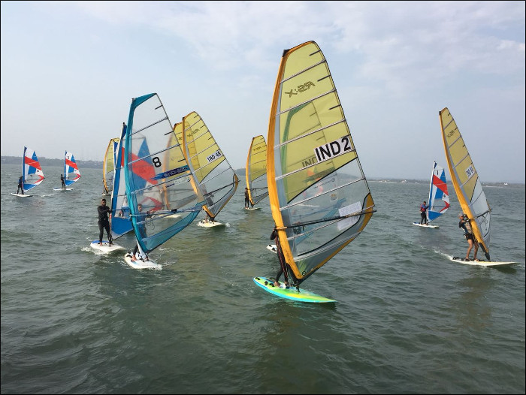

Fig 4.6: Windsurfing

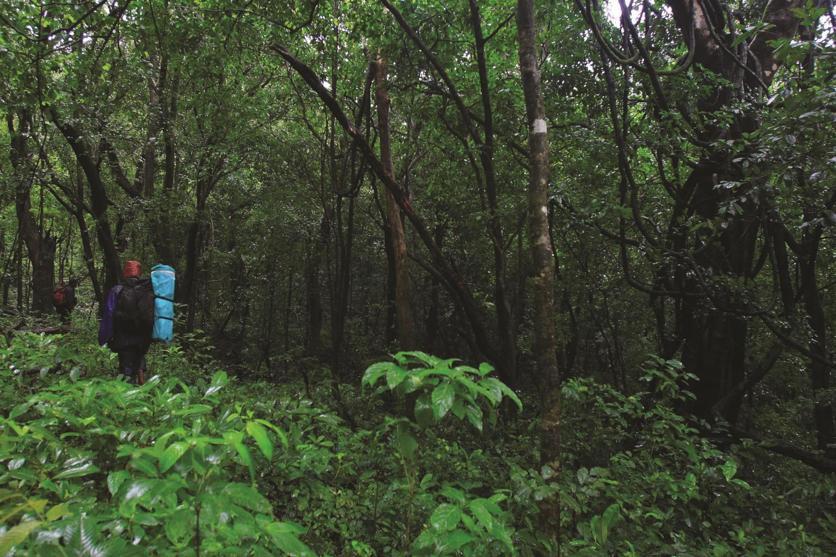

Fig 4.7: Trekking

**Wildlife in and around Gokak**

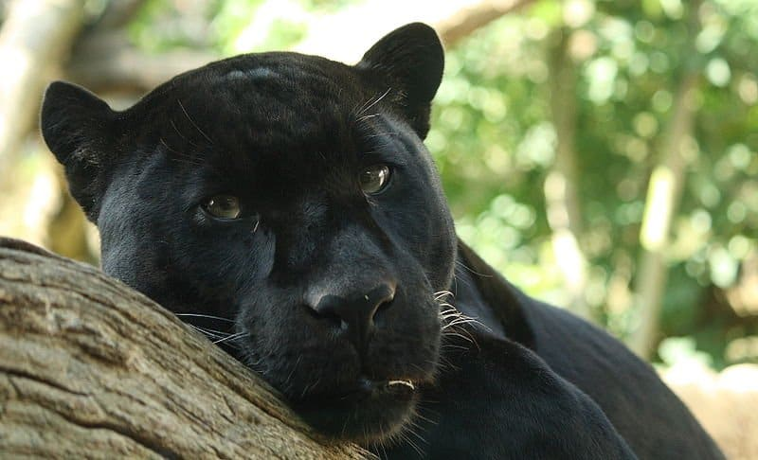 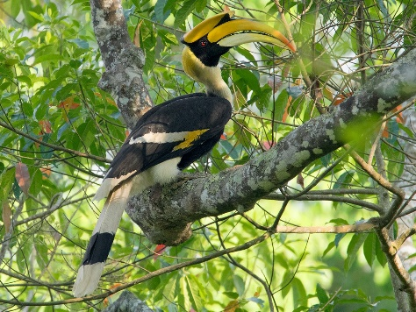

Fig 4.8: Black Panther Fig4.9: Indian hornbill

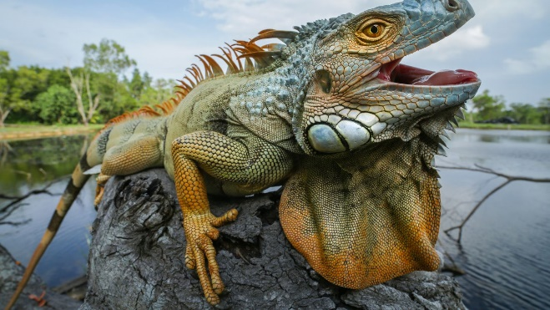 

Fig4.10: Iguana Fig4.11: Bison

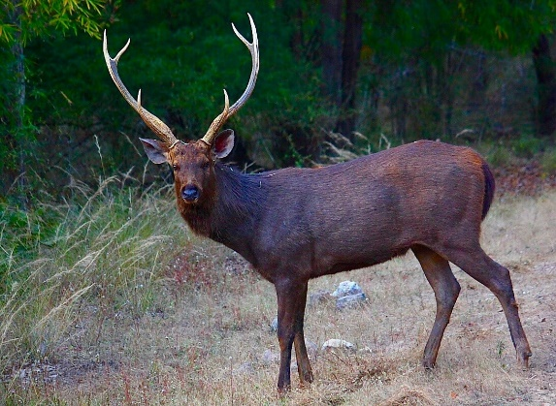 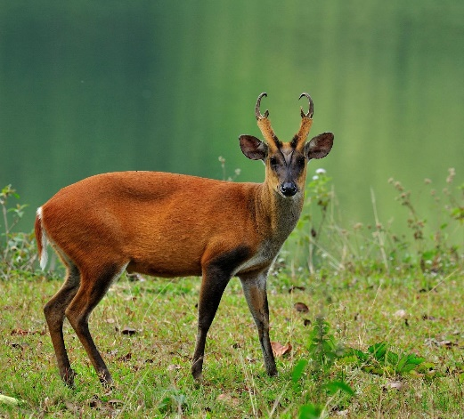

Fig4.12: Sambhar Fig4.13: Barking deer

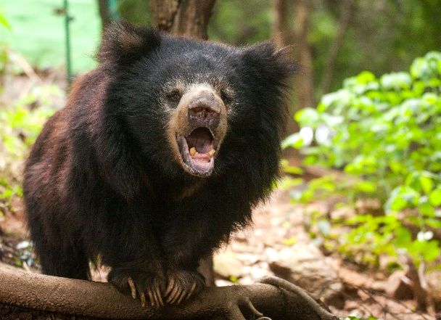 

Fig4.14: Sloth Bear Fig:4.15 Malabar Squirrel

Travellers can visit Belgaum for more recreational activities. Belgaum is just around 70 km from Gokak.

The gorgeous landscape of Belgaum is endowed with gurgling streams, majestic waterfalls, verdant hillocks and narrow winding forest lanes, making it the perfect place for trekkers and hikers. One of the best trekking routes in Belgaum is the trek to the Shimbola Waterfalls. The cascading falls provides an exciting trail of 10-12 km, and the trek can be accomplished within five hours. Another great option for trekking is Sada Village, wherein you get to explore a diverse landscape. During this trek, you can stop at an ancient fort built by the rulers of the Kadamba dynasty (345-525 CE), relax at a gorgeous waterfall surrounded by dense forests and crawl through volcanic caves or try your luck at spotting the mysterious Mother Mary Rock. Tourists can also opt for the remarkable trek to Kalsa and Sural valleys, wherein they will get an opportunity to stroll through the wilderness in the Kankumbi forests. It usually takes around four hours to complete the trek, which involves navigating through boulders in the river and pushing against challenging steep ascends and descents. Belgaum is also famous for its jungle trekking trails, which can be taken on even by beginners. Experienced guides take tourists around the Dandeli jungles. If you are lucky, you can get a chance to spot wild animals like black panther, Malabar squirrel, sloth bear, barking deer, sambar, bison, iguana, cobra, elephant, and birds like the great Indian hornbill.

# Restaurants and Amenities near Gokak Falls

# Restaurant near Gokak falls

Niyaaz Hotel

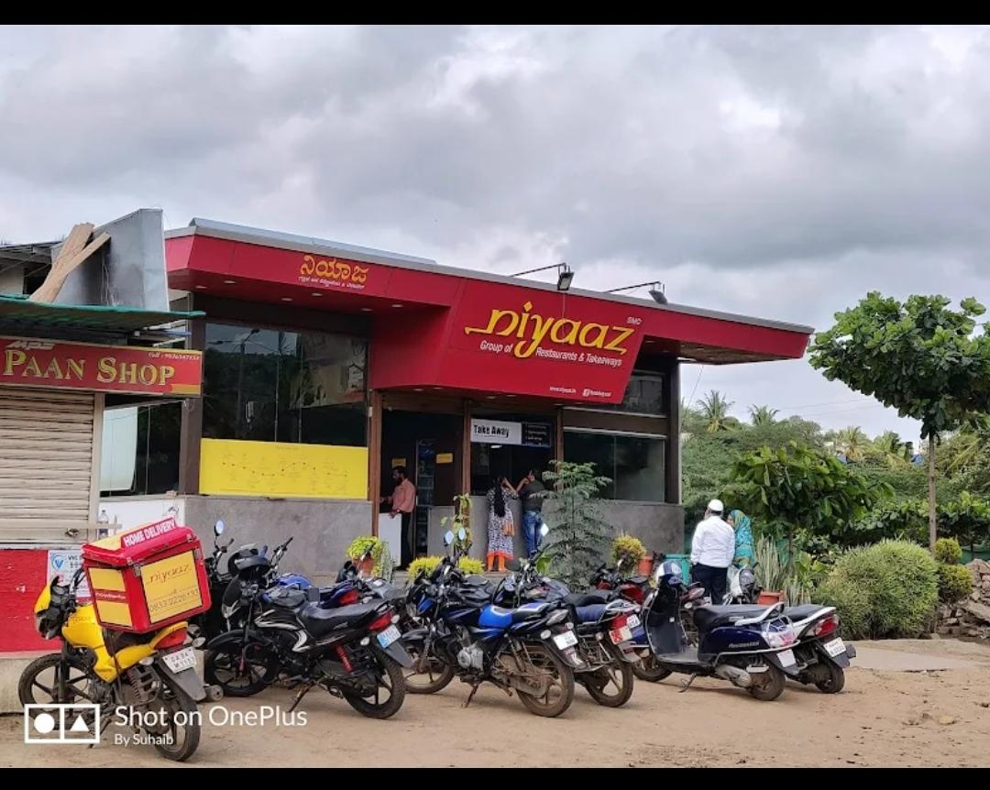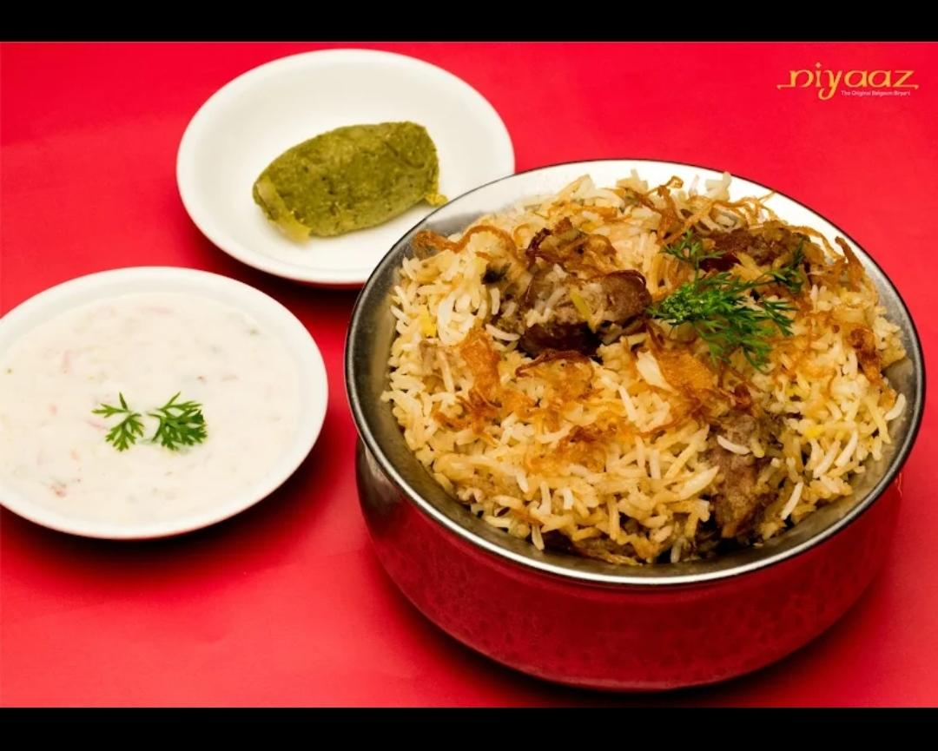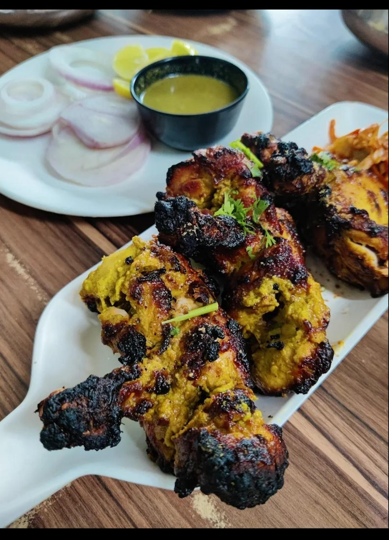

Fig 5.1

<https://g.co/kgs/TH7kDW>

About :

NIYAZ Gokak is the awesome place foodies. Ambience is OK food is exceptionally well. Especially for kebabs and burying indum style cooking. This restaurant offers its guests Chinese and Indian cuisines. At Niyaaz, the recipe of perfectly cooked biryaniis a story that ends up with a really good meal. The accommodating staff works hard, stays positive and makes this place great. The terrific service displays a high level of quality at this place. Categories-Biryani restaurant, Chinese Restaurant, IndianRestaurant, NonVegetarian Restaurant. Order food online from Niyaaz Restaurant, Gokak Locality, Gokak and get great offers and super-fast delivery on Zomato. Gokak niyaz contact number 08332226133.

The Underground Palace

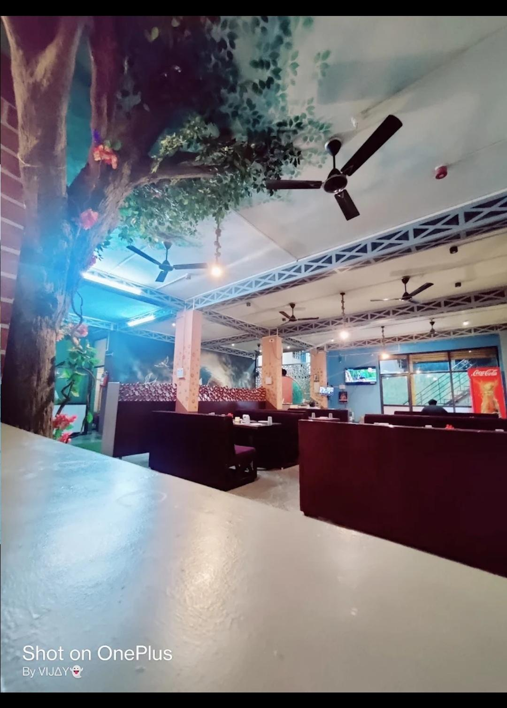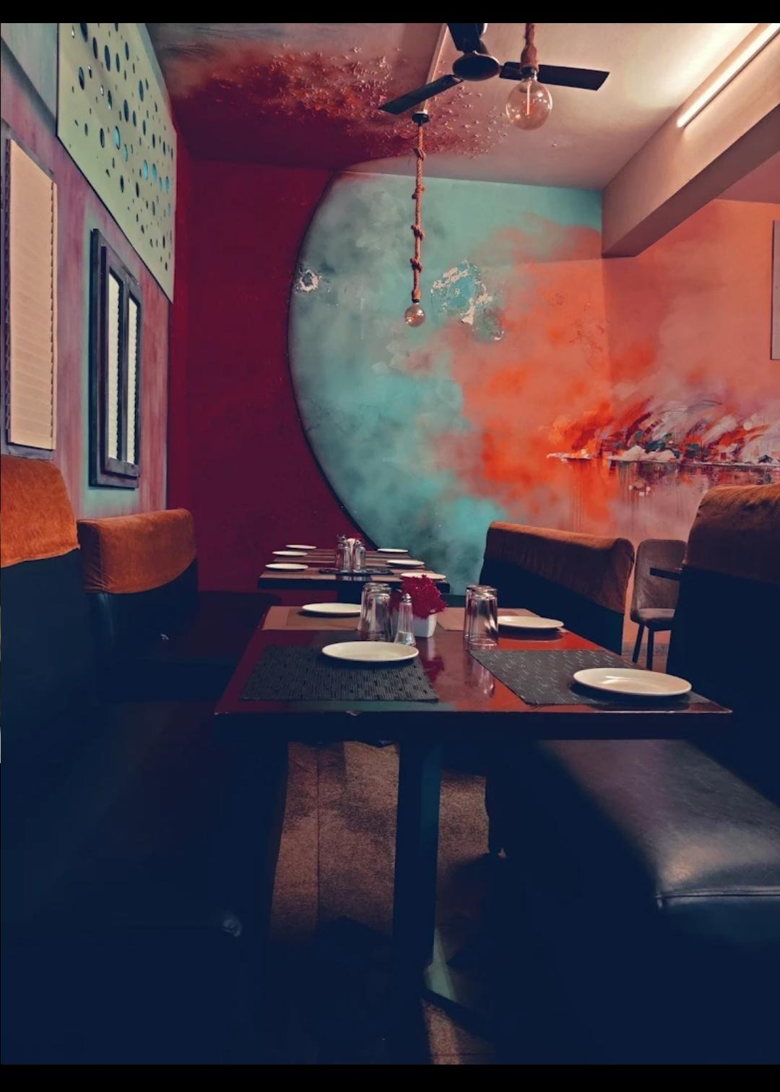

Fig 5.2

<https://g.co/kgs/5sTxXU>

About :

Underground palace in gokak, belagam underground palace listed under restaurant in gokak, belgaum. check address, location, contact number, ratings and reviews, photos, maps etc on justdial. Location and overview underground palace in gokak, belgaum is are liable name inindustry as they aim to deliver the best experience to the customers. This has helped them to build up a loyal customer base. They started their journey in and ever since, they have ensured that the customer remains at the centre of their business operations and philosophy. As they are located in favourable neighborhood, exactly at hattikattige building, gokakfalls road- 591307. It is easy to locate underground palace in map. For any kind of assistant and questions, it is best to contact them directly during their business hours. It is the pure veg restaurant in gokak.

Spice Garden

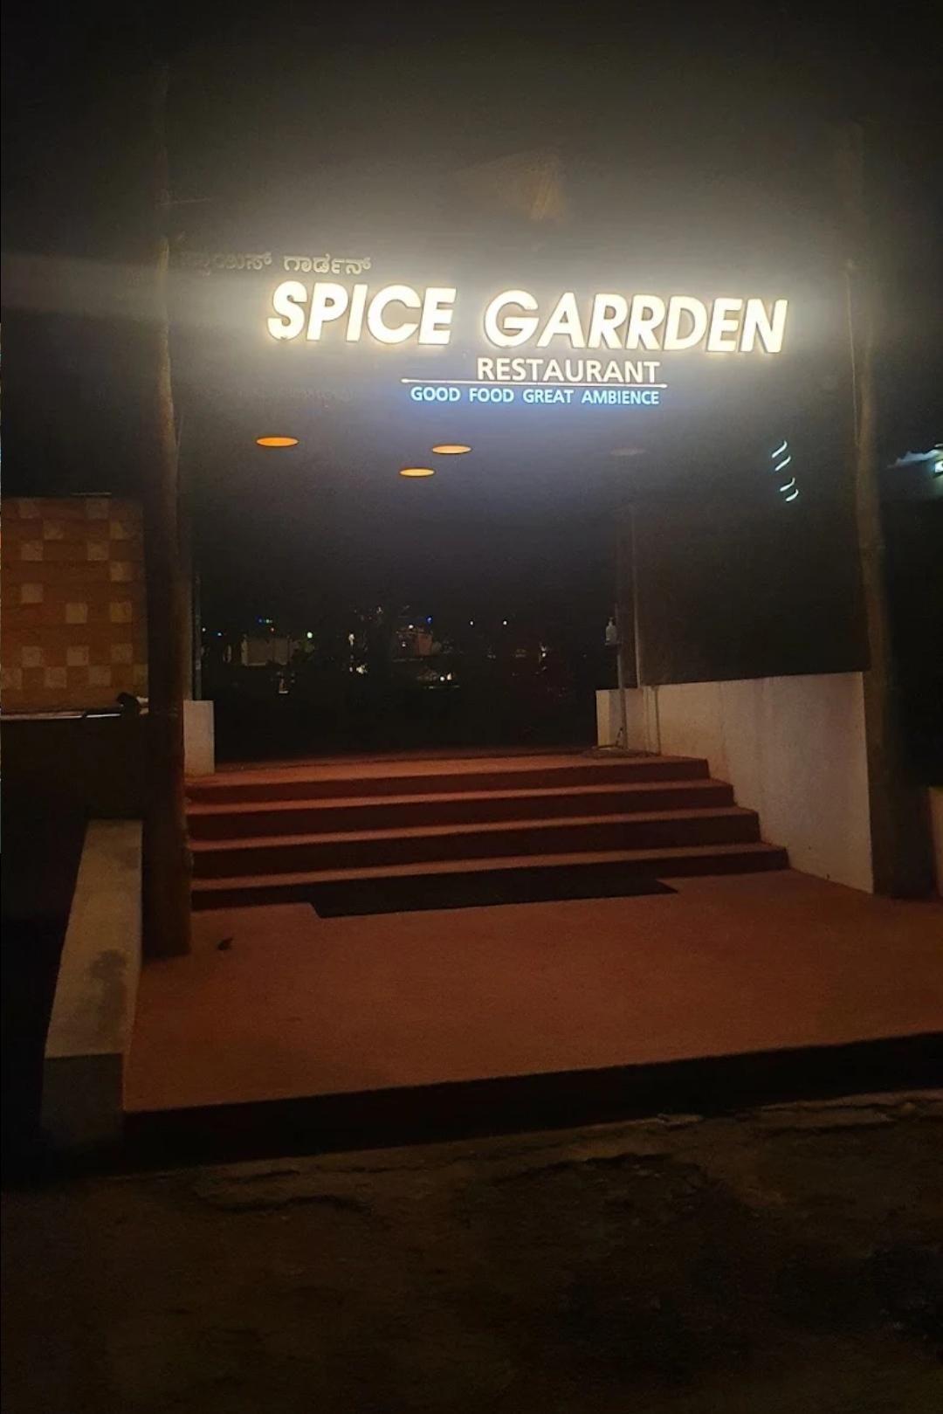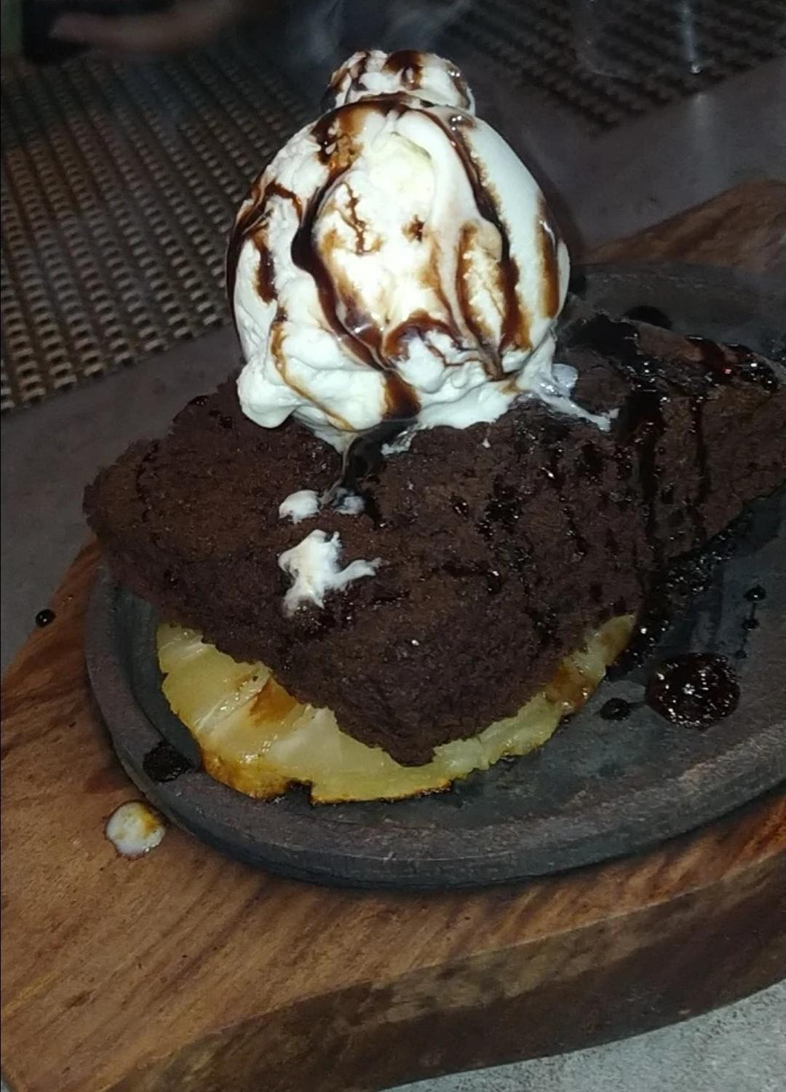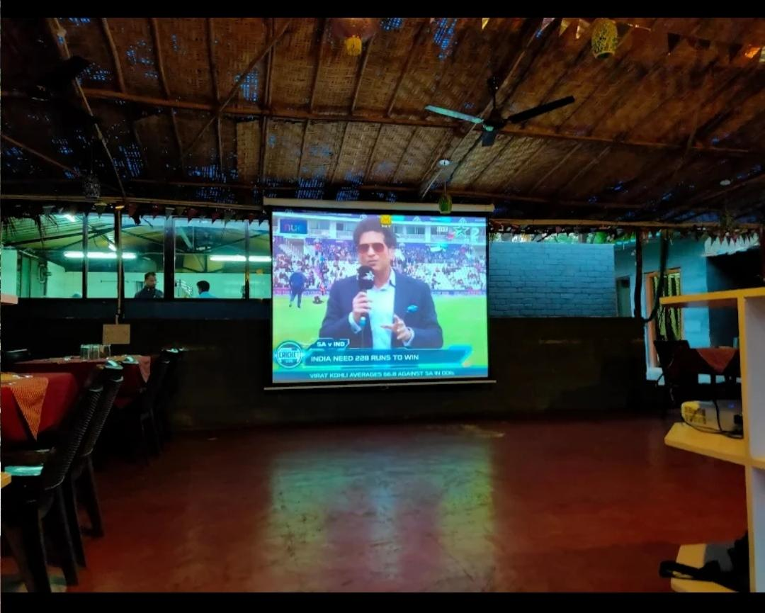

5.3

<https://g.co/kgs/nx2AeS>

About :

An authentic Multicuisine Restaurant serving Indian,Tandoor,Chinese,Italian and Mexican cuisine. Yogikolla Road,Gokak., Gokak, Karnataka, India 591307. Spice Garden Gokak, #1 among Gokak restaurants :568 reviews by visitors and 20 detailed photos. Find on the map and call to book a table. Indian cuisine will be what you are offered to try at this restaurant. Many people mention that the staff is cheerful at Spice Garden Gokak. Cool service is something visitors agree upon here. If you come to this place, have no doubt, you are to enjoy the surrounding calm ambiance. Google users awarded ther ating of 4 to this spot. The restaurant serves cuisines like PureVegetarian,Jain,Indian.

Spice garden gokak contact number -09741800400

Parks near gokak falls26

Kemple park

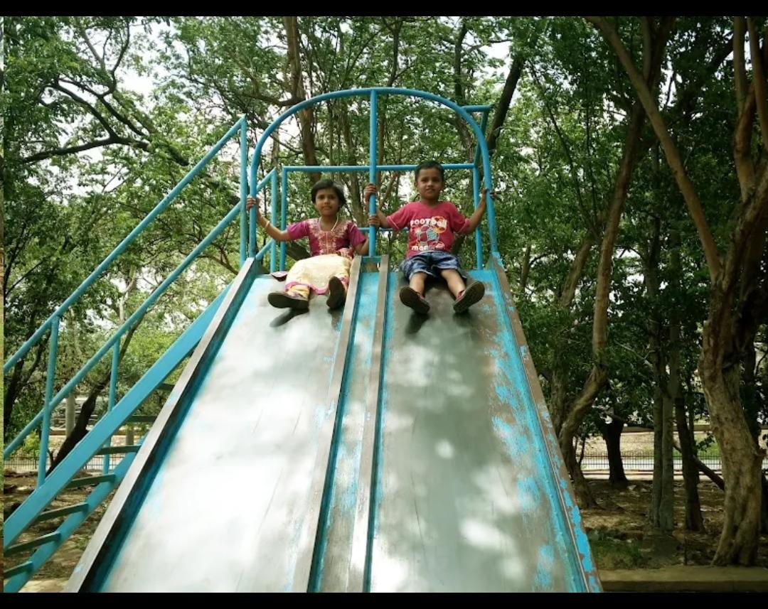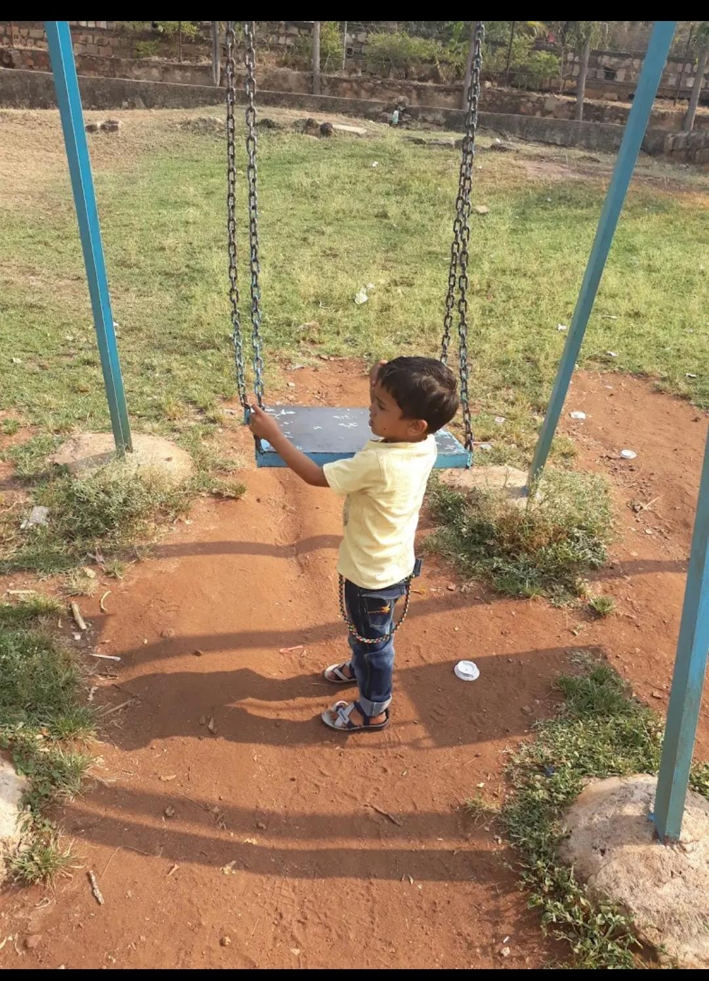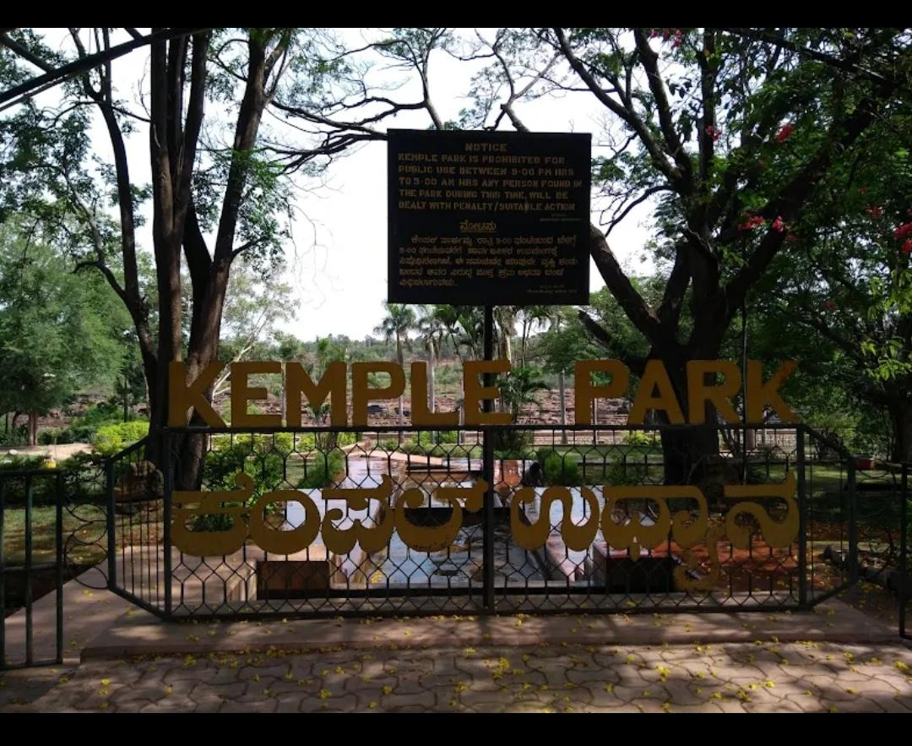

5.4

<https://g.co/kgs/hSCnUh>

About :

Situated on the Gokak Falls Road, Kemple Park is the perfect destination for you to visit. The mist formed by the falling water of the falls and the scenic splendor of the place is simply breath-taking. The mesmerizing beauty of the waterfall and the splendid forest cover makes it an ideal trekking destination. It is also a popular picnic spot for the tourists. The park fascinates the visitors with its unique surroundings that comprise lakes and lush green cover. You can also relax beside the water canal, which adds to the beauty of the park. Watch the flock of birds can be easily observed near the water canal and the scenery is quite eye-catching at sunset when they fly back to their nests. Enjoy at the Kemple Park and make your visit to Belgaum memorable.

Gokak falls view point

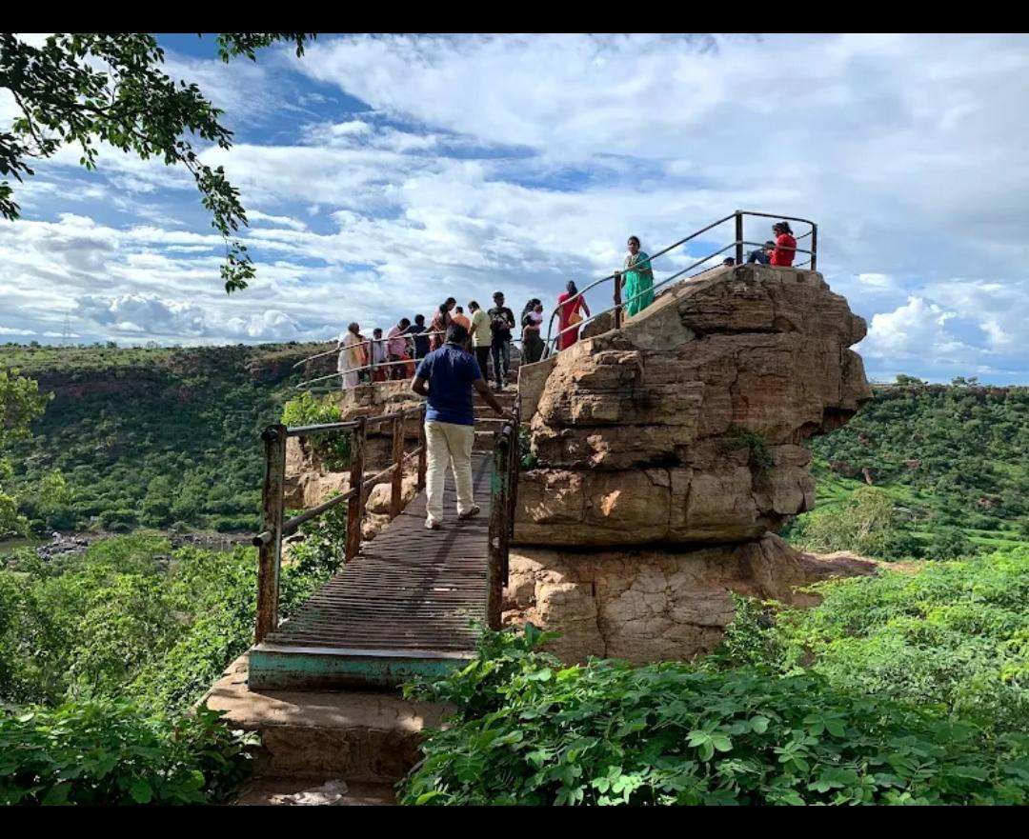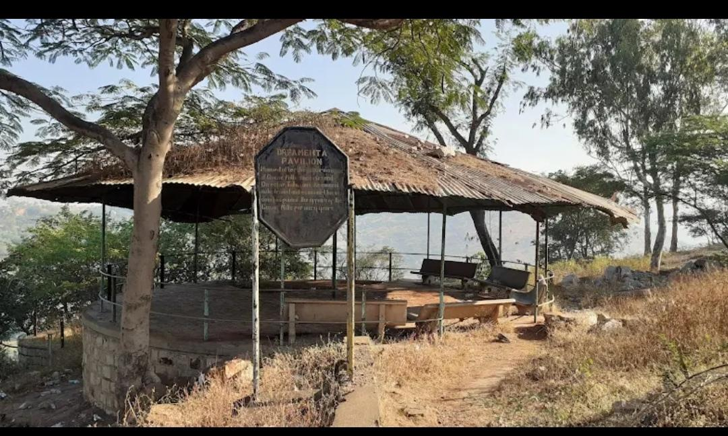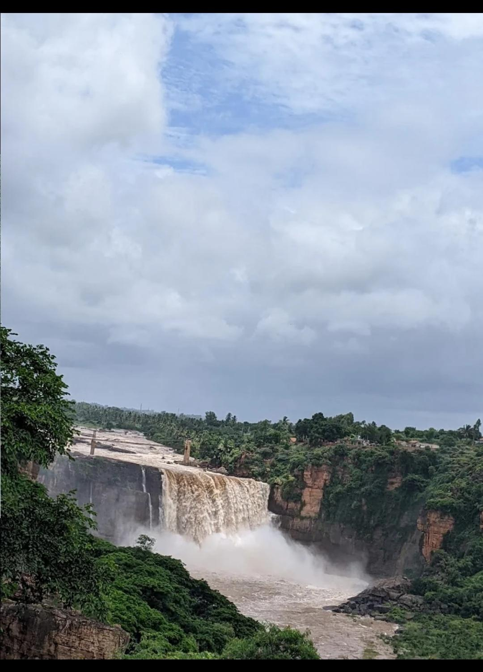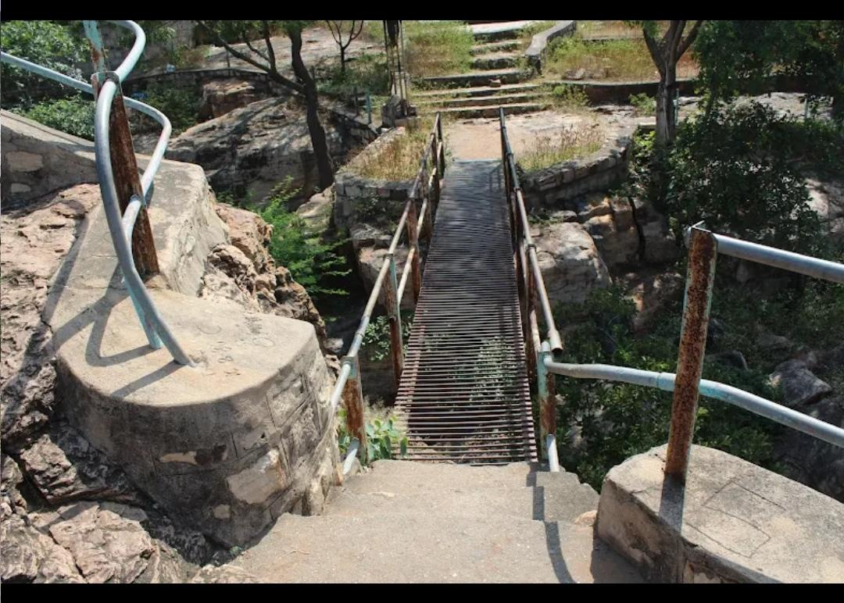

Fig 5.5

<https://g.co/kgs/hrARz6>

About :

Gokak Waterfalls is one among the recognized tourist attractions by the Government in Belagavi district. Gokak Waterfalls is situated 6 Kms from Gokak City. Hanging bridge, Mahalingeshwar temple, Heritage buildings of Gokak Mills are the various other attractions at this spot.

Tourists come here in large numbers during Rainy season, Sundays and other holidays. It’s a good picnic spot as there is a garden and established viewpoints to have splendid look of the waterfalls.

Great place to visit to spend seeing the big waterfall. During rainy seasons the water levels swell up and flow is also quite forceful and speedy, so care must be exercised. Water falling from about 70 metre height in to the gorge make it beautiful and enormous. It can get crowdy at most times and care must be exercised at all times as there is no rails for protection and water flow is unstoppable.

Hotels near gokak falls

Hotel Landmark

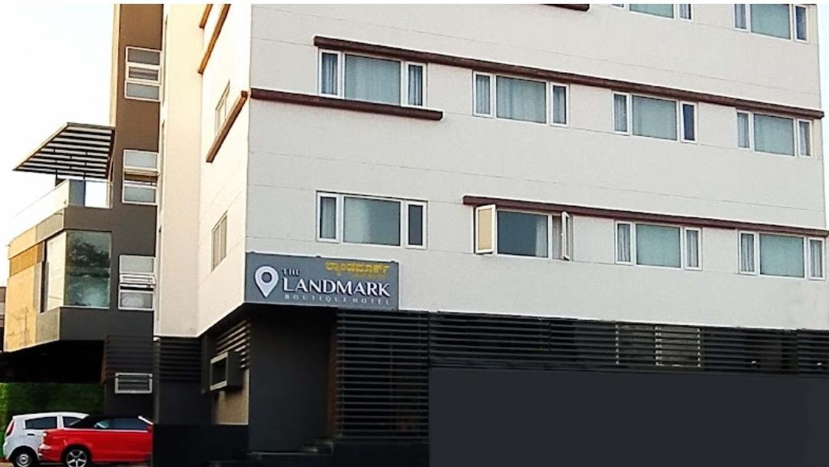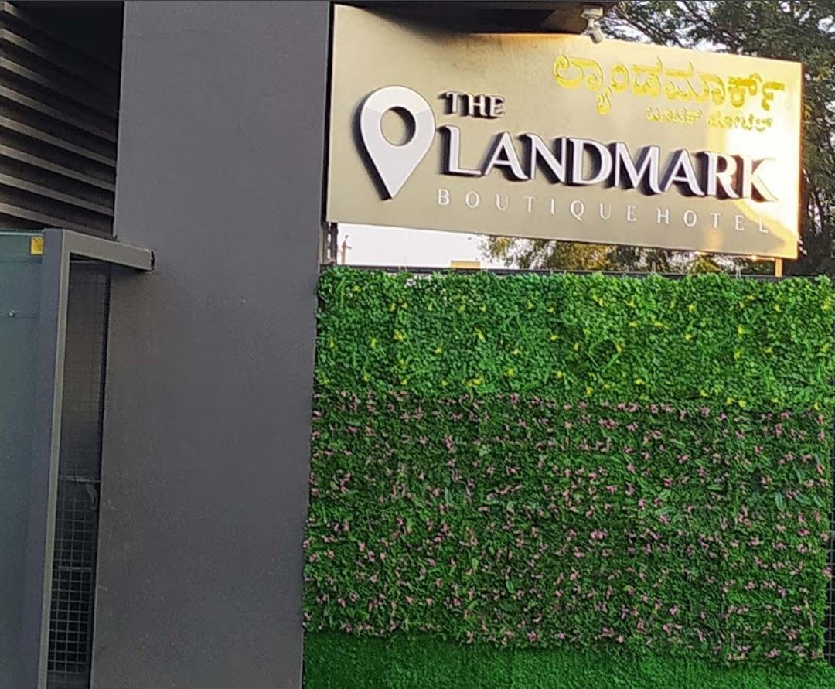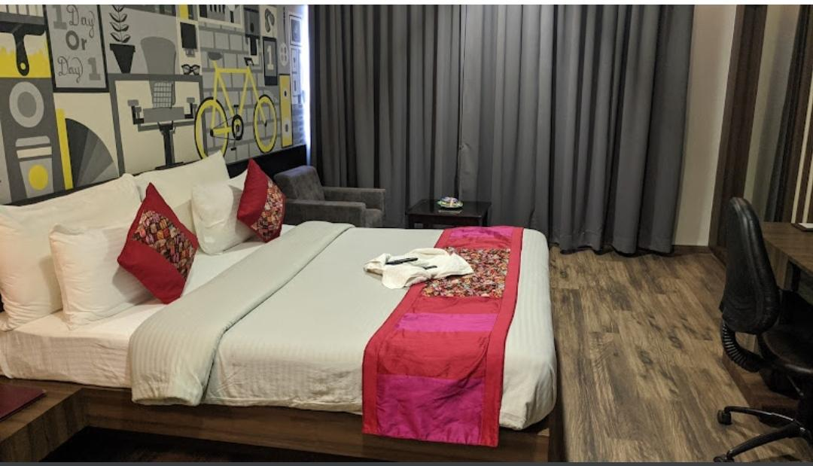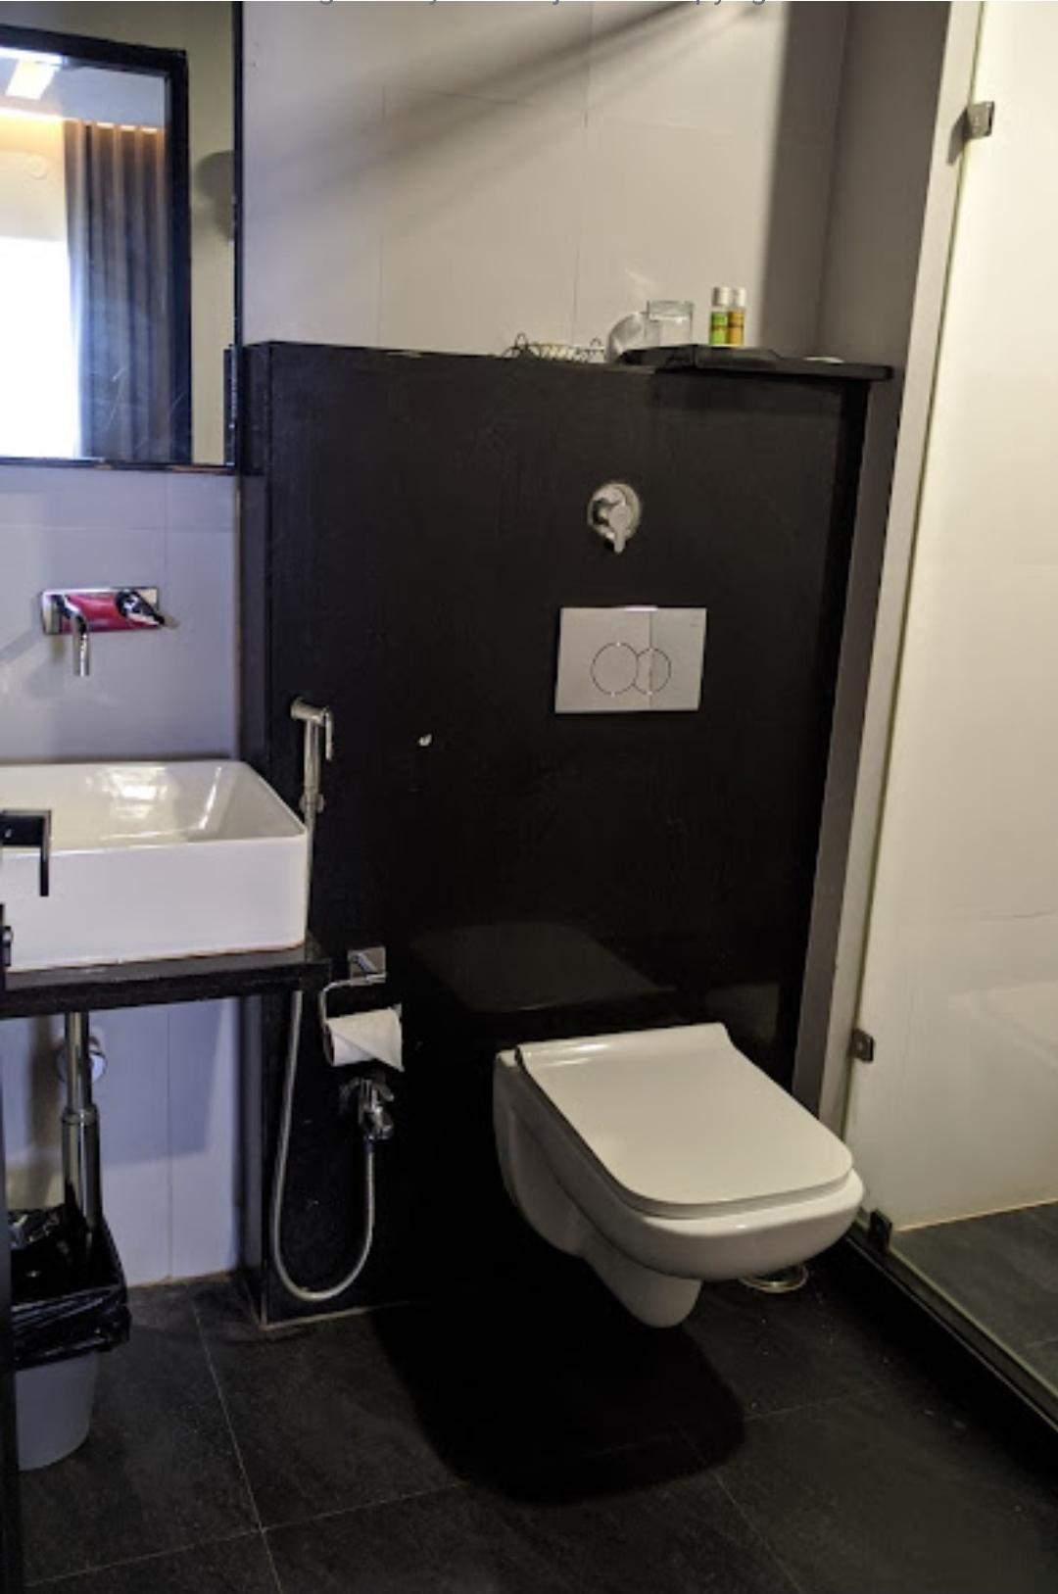

Fig 5.6

About :

Situated in the heart of city. Luxurious accommodation coupled with 3 dining options. Just 2 minutes drive from the busterminal. The Landmark Hotel in Gokak is one of the most trustworthy names in the field. They have received a 4.1 rating from their coustomers. The Landmark Hotel is a great choice for travellers looking for a budget accomodation in Gokak. It is located in Vivekanand Nagar. The Landmark hotel Gokak with three star facilities is situated in the heart of the city. Luxurious accommodation coupled with 3 dining option. The Landmark hotel contact number: 09900162720.

Hotel Gokak Resort

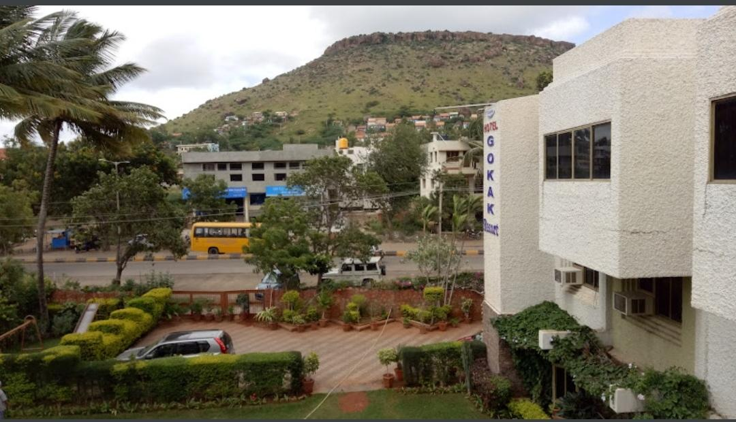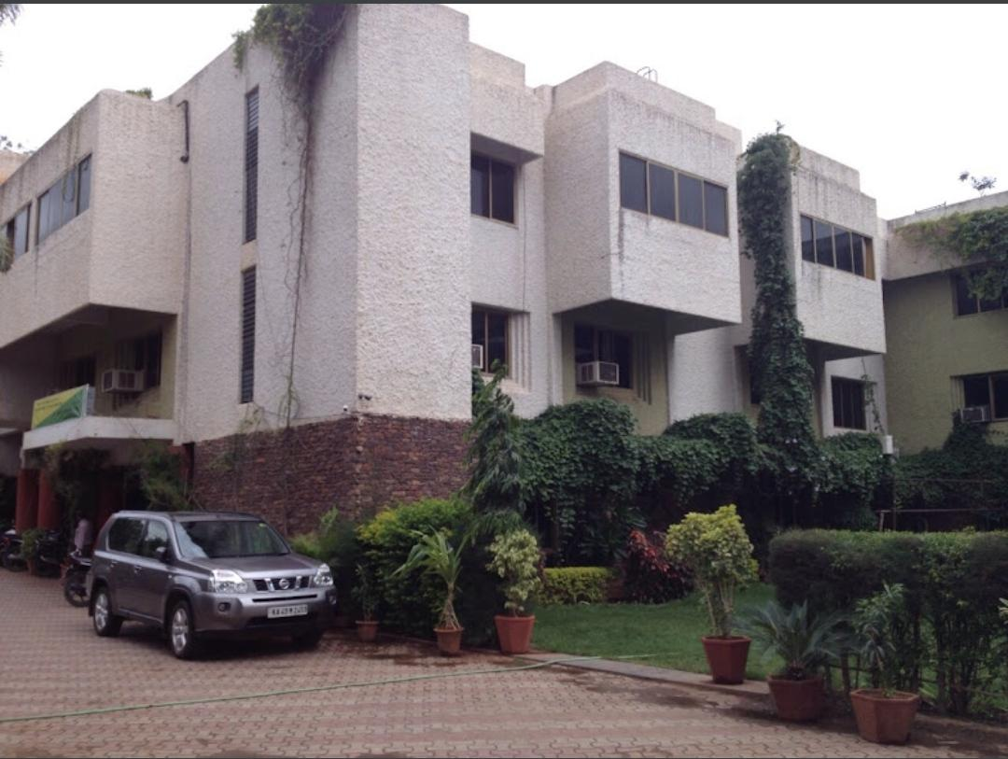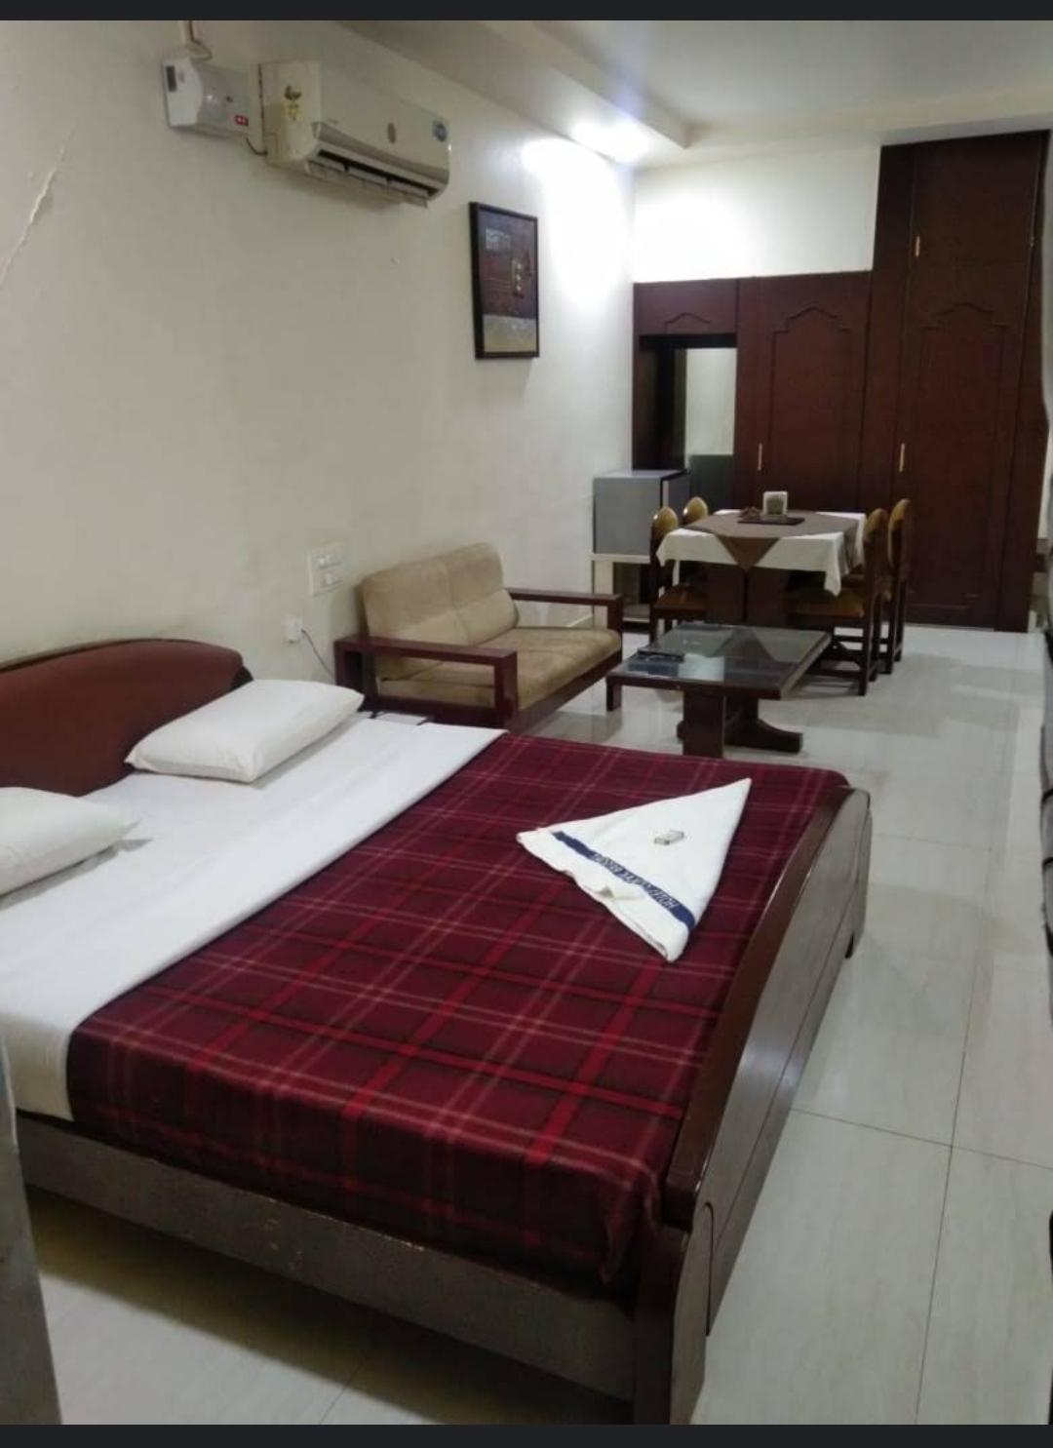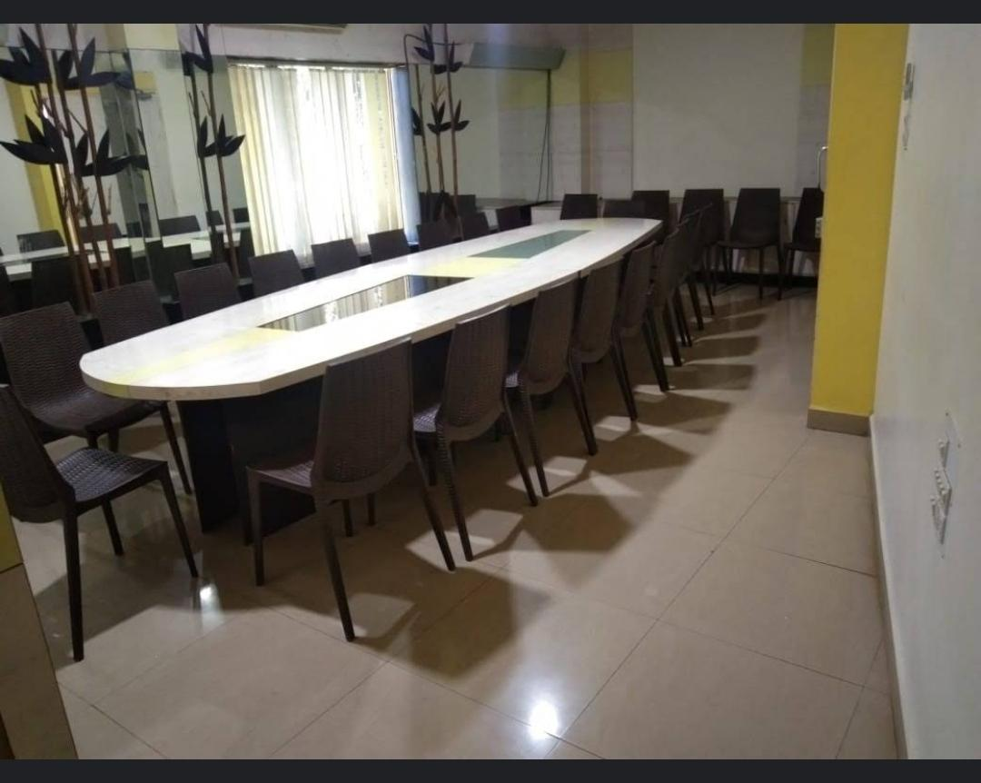

Fig 530

About :

Conveniently located on the Gokak falls road, not very far off from the amazing Gokak falls. Nearest airport is Belgaum. There are flight available from Mumbai. Nearest big station is Ghataprabha where all the trains stop. There is another small station Gokak Road, where most of the good trains do not halt. From airport it is 90 minutes and from Ghataprabha, it is 30 minutes journey. If you want to visit Gokak falls, at a very reasonable price, this is a nice hotel. Staff are very polite and helpful, rooms are good. Excellent service. food which is very nice and tasty.

References

1. Wikipedia ([Gokak - Wikipedia](https://en.wikipedia.org/wiki/Gokak))
2. Karnataka Tourism (https://www.karnatakatourism.org/tour-item/gokak-falls/)